**Android Mobile Application: Expense Tracker**



This is a paper to document a final project submitted to the

Faculty of the School of Graduate Studies

In partial fulfillment of the requirements for the degree of

Master of Science

In

Computer Information Systems

By

Ahmad Atiyah

Southern University at New Orleans

College of Business and Public Administration

Department of Computer Information System

Fall 2014Abstract

Keeping track of daily expenses is an important and fundamental way of having a manageable budget. Many people around the world face difficulties in managing daily expenses due to their inability to keep track of their daily financial transactions. This project was created as an attempt to mobilize the process of tracking daily expenses by allowing people to use their smartphones to track daily income and expense transactions. This was accomplished by creating a mobile application that works on all android smartphones. The application was developed using “App Inventor for Android”, an open-source web application provided by Google, and maintained by the Massachusetts Institute of Technology (MIT). It allows users to create mobile applications for the Android operating system (OS) using a graphical interface, which allows users to drag-and-drop visual objects to create their application. The application “Expense Tracker” allows users to record their financial transaction (incomes and expenses) on the go by entering the transaction details into the app. The app then stores, calculates and displays the sum of the user’s expense, incomes, and balance. It also gives the user the option of reviewing all the transactions that were recorded via Expense Tracker.

Table of Contents

List of Figures 3

Introduction 5

Background 7

Expense Tracker: Description 10

Building an App Using App inventor 11

Requirements 11

Setting App Inventor for Windows 12

Java Preparation 13

App Inventor Instructions 13

Building Expense Tracker 15

Home Screen “Screen1” 15

Welcome Screen 18

Summary Screen 20

Add Income/Expense Screen 27

History Screen 37

References 41

# 

# List of Figures

1. Retailers Mobile Apps6

2. Smartphone OS Market Share9

3. Logged In Page13

4. New Project Page13

5. Screen114

6. Screen1 Blocks16

7. Welcome Screen Designer View17

8. Welcome Screen Blocks18

9. Summary Screen Designer View19

10. Summary Screen Blocks 122

11. Summary Screen Blocks 222

12. Summary Screen Blocks 323

13. Summary Screen Blocks 423

14. Summary Screen Blocks 524

15. Summary Screen Blocks 624

16. Summary Screen Blocks 725

17. AddExpense Screen Designer View26

18. AddExpense Screen Blocks 129

19. AddExpense Screen Blocks 229

20. AddExpense Screen Blocks 330

21. AddExpense Screen Blocks 430

22. AddExpense Screen Blocks 531

23. AddExpense Screen Blocks 633

24. AddExpense Screen Blocks 734

25. AddExpense Screen Blocks 835

26. History Screen Designer View36

27. History Screen Blocks 137

28. History Screen Blocks 238

29. History Screen Blocks 339

# Introduction

Despite improvements in the global economy, PC sales declined by almost 14% compared with the same period the previous year marking the 4th straight quarter of shipment declines. On the other hand, sales of mobile phones grew 4% year over year in the seasonally slow first quarter of 2013 (IDC, 2013). Individuals and enterprises have been affected by this growth and became dependent on the advantages and benefits that come with this technology.

The history of mobile devices goes back to over three decades from now, where the Motorola DynaTAC 8000X was the first mobile phone available commercially. The competition was fierce and manufacturers were doing their best to keep all their secrets in house. Nokia was the first to produce mobile applications, where they released the famous video game, Snake, on some of their devices (Clark, 2012).

Mobile devices and mobile applications are spreading throughout businesses. Enterprises have become very dependent on the technology and the demand has been increasing significantly. Companies such as Sears and Home Depot believe the customer experience can be greatly enhanced by providing mobility to sales representatives. Both companies employ the use of mobile technology to enable on-the-spot research to be provided while with the customer. The technology is allowing sales and technical staff to provide real-time inventory, delivery, or customer data systems.

Additionally mobile technology is ever present to the customer. The majority of mobile device users have their preferred device within arm’s reach most of the time allowing real-time access to information as well as the ability to choose which product they want and when. This shows the importance for business to understand a vast majority of mobility focus is based on the consumer. Businesses are being forced to study and analyze the way they operate and how they can adjust their structures in order to benefit from the technology and overcome any challenges that come with it. Those businesses that understand how mobile computing and applications can change processes, lower costs, and even redefine a company’s place in their respective industry.

Those that understand will win customers and likely soon will be reaping the rewards.

Smartphones and tablets have helped businesses and employees work faster and be able to perform remotely which is an advantage they didn’t have 10 years ago. This advantage contributed in making employees more productive and more efficient by increasing their agility and being able to perform even when they are away from their desks. Sharing information from the field is now possible as well as email communication, social media, and accessing company data on a mobile device.

“Today, the U.S. consumer spends an average of 2 hours and 38 minutes per day on smartphones and tablets. 80% of that time (2 hours and 7 minutes) is spent inside apps and 20% (31 minutes) is spent on the mobile web.” (Khalaf, 2013).

# Background

The first generation of mobile applications, as we know them today, was when Steve Jobs, Apple’s former CEO, announced the release of the first iPhone in the beginning of 2007, says Honan (2007). The availability was limited to applications developed by the manufacturer but that did not last for very long as third party developed applications started appearing in the app markets after a very short period of time. Other companies such as Google and Microsoft released their mobile application stores (Google Play and Windows App Store) and started competing in the market.

61% of customers who visit a mobile site that does not meet or exceed expectations will likely head to competitor (Brill, 2013). This is evident in the number of retail sites that use mobile site technology. Sterling (2013) says that The Search Agency found that 91% of multichannel retailers reviewed had dedicated mobile sites.

Mobile sites can be categorized or ranked according to load times, site format, store locator, search box options, social media, and applications.

*Source: Sterling, G. (2013)*

Figure 1: Retailers Mobile Apps

Those with higher rankings based on weighted systems would typically have increased sales and better customer retention.

Mobile Applications allow customers to interact with retailers with a loyal following. Meaning that the majority of customers don’t need or want a mobile application; however, they do require a positive mobile experience of the more broadly used mobile website. Figure 1 shows the percentage of mobile app adoption and availability in several industries.

People have been using their mobile devices to browse the internet, check their emails, practice some online shopping; however, another recent addition is computing via mobile in the workplace. Since smartphones and tablets are more portable than a desktop or even a laptop, employees started using their own mobile device for work related purposes when portability is a key. Employees like the comfort of being able to be productive on devices of their choice. They feel more comfortable and are able to continually feel connected to the organization.

As a result, businesses have begun the Bring Your Own Device (BYOD) policy to control and protect this kind of practice. However, the adoption of BYOD comes with challenges for the enterprise and its IT department. According to Cisco (2013), more and more personal mobile devices are being used for work related purposes; therefore, it is virtually impossible to have a list of pre-approved devices that are allowed to access the enterprise’s network and/or access its data. With this policy, IT departments have to come up with a new method of controlling this king of access and bear in mind a very critical factor which is security (Cisco, 2013, p. 9). One such method is developing company apps that require secure log-in functions; however, allow the same access and features as desktop applications.

This means different infrastructures, different rights management, and access security precautions. Some organizations chose to adopt a different policy, Choose Your Own Device (CYOD), where the employee gets to choose from a range of pre-approved devices that are already connected to the IT/organization infrastructure, have their approved anti-virus and software (Patrick-Smith, 2012).

The mobile app market these days is mainly dominated by Google. Android shipments lead the global smartphone market, with 283 million units shipped and over 84% of the market share in the third quarter of 2014. Android average selling prices have been plummeting to maintain this share, hitting US$230 in third quarter, down from US$267 the same quarter the year before. Samsung's lead was further chipped away as Chinese players like Xiaomi and Lenovo made yearly gains. However, the strength of the long tail of regional and local vendors is where many of the gains came from, as the top 5 collectively accounted for 52% of shipments, down from the top 5 a year ago with 62.0% share (IDC, 2014).

IDC says that Apple’s iOS continues to drop in market share, down to just 11.7% from 12.8% in the same quarter last year, representing the growing shift of demand toward low-cost smartphones. The launch of the iPhone 6 and 6 Plus at the very end of the third quarter means that the bump in shipments will be reflected fully in the fourth quarter holiday season.

Windows Phone dropped year over year, but was up sequentially from the second quarter, reflecting a change in vendor dynamics. While over 90% of Windows Phone shipments have consistently been driven by Microsoft (Nokia) Lumia models, partnerships with other vendors have shifted over the year away some of the bigger name vendors like Samsung and HTC toward a number of regional and local players, attracted by free Windows Phone licenses, announced in second quarter (IDC, 2014).

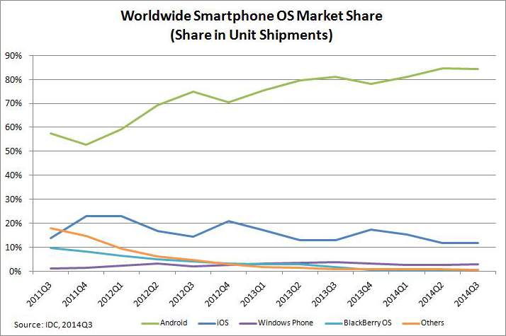

Figure 2: Smartphone OS Market Share

# Expense Tracker: Description

Expense Tracker is a mobile application for mobile devices with Android OS. The App assists users keep track of their day-to-day expenses. Users can manage their incomes, expenses, and review their balances at any time. The App is easy to use. Here are some tips on how to best use the App:

* From the "Summary" screen, users can display their current income amount, expense amount, and balance. They can also add an expense, add an income, reset their tracker, and review the history of their transactions.
* Users can add an Income or Expense by clicking on the ("+INCOME" or "+EXPENSE") buttons located on the "Summary" screen.
* Add Income: to add an income, users need to enter (Date of transaction, Income Type, and Income Amount) in the Add Income screen. Once the values are entered, users need to click the "Submit" button to save these values.
* Add Expense: to add an expense, users need to enter (Date of transaction, Expense Category, and Expense Amount) in the Add Expense screen. Once the values are entered, users need to click the "Submit" button to save these values.

# Building an App Using App inventor

The app was built using a tool provided by Google. The tool is called “App Inventor” and can be used by simply logging into the App Inventor page using a Google account. The App Inventor page can be accessed at the following link: (ai2.appinventor.mit.edu/).

In order to use this tool, the computer used needs to be prepared by following a certain method.

## Requirements

The following are the minimum requirements that need to present in order to use App inventor:

*Computer and operating system:*

Macintosh (with Intel processor): Mac OS X 10.5 or higher

Windows: Windows XP, Windows Vista, Windows 7

GNU/Linux: Ubuntu 8 or higher, Debian 5 or higher - NOTE: GNU/Linux live development is only supported for WiFi connections between computer and Android device.

*Browser:*

Mozilla Firefox 3.6 or higher

Note: If you are using Firefox with the NoScript extension, you'll need to turn the extension off. Apple Safari 5.0 or higher

Google Chrome 4.0 or higher

Microsoft Internet Explorer is not supported

Phone or Tablet (or use the on-screen emulator)

*Mobile OS:*

Android Operating System 2.3 ("Gingerbread") or higher

## Setting App Inventor for Windows

The machine that was used to create Expense Tracker has Windows as the operating system. There are a few steps to follow prior to using App Inventor to ensure the reliability of the tool. These tools are listed below:

1. Download the installer using the following link: (http://dl.google.com/dl/appinventor/installers/windows/appinventor_setup_installer_v_1_2.exe).
2. Locate the file AppInventor_Setup_Installer_v_1_2.exe (~92 MB) in the Downloads file or Desktop. The location of the download on the computer depends on how the browser is configured.
3. Open the file.
4. Click through the steps of the installer. Do not change the installation location but record the installation directory, because it will be needed to check the driver. The directory will differ depending on the version of Windows used and whether or not the user is logged in as an administrator.

## Java Preparation

To verify that Java Web Start is working properly, users should click the orange "Launch" button from the page that can be accessed via the link (http://appinventor.mit.edu/explore/test-your-system.html) to try to launch a program from the Web. This test should download and run a file (notepad.jnlp), which will create a window named "Notepad" where the user can enter text. Depending on the browser, users might need to manually open the jnlp file after it downloads.

If Notepad does not run, then the test fails. Users should not go on to try to use App Inventor. If the test passes, then close the Notepad window and go on.

## App Inventor Instructions

Once the user is logged in via a Google account, the user will have the following page:

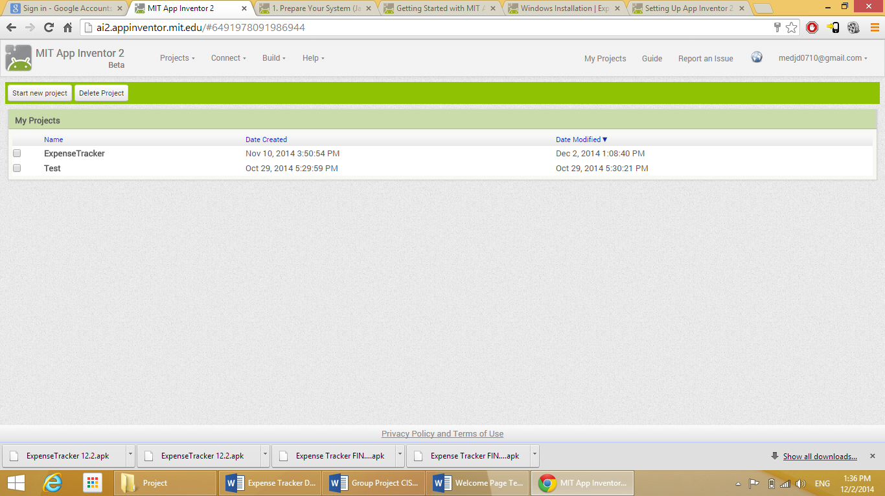

Figure 3: Logged In Page

This page displays the current projects that the user has developed. For the first log in, the page will be blank. To create/start a new project, the user can click the “Start new project” button on the top left part of the screen. Once the button is clicked, the user will have the following screen: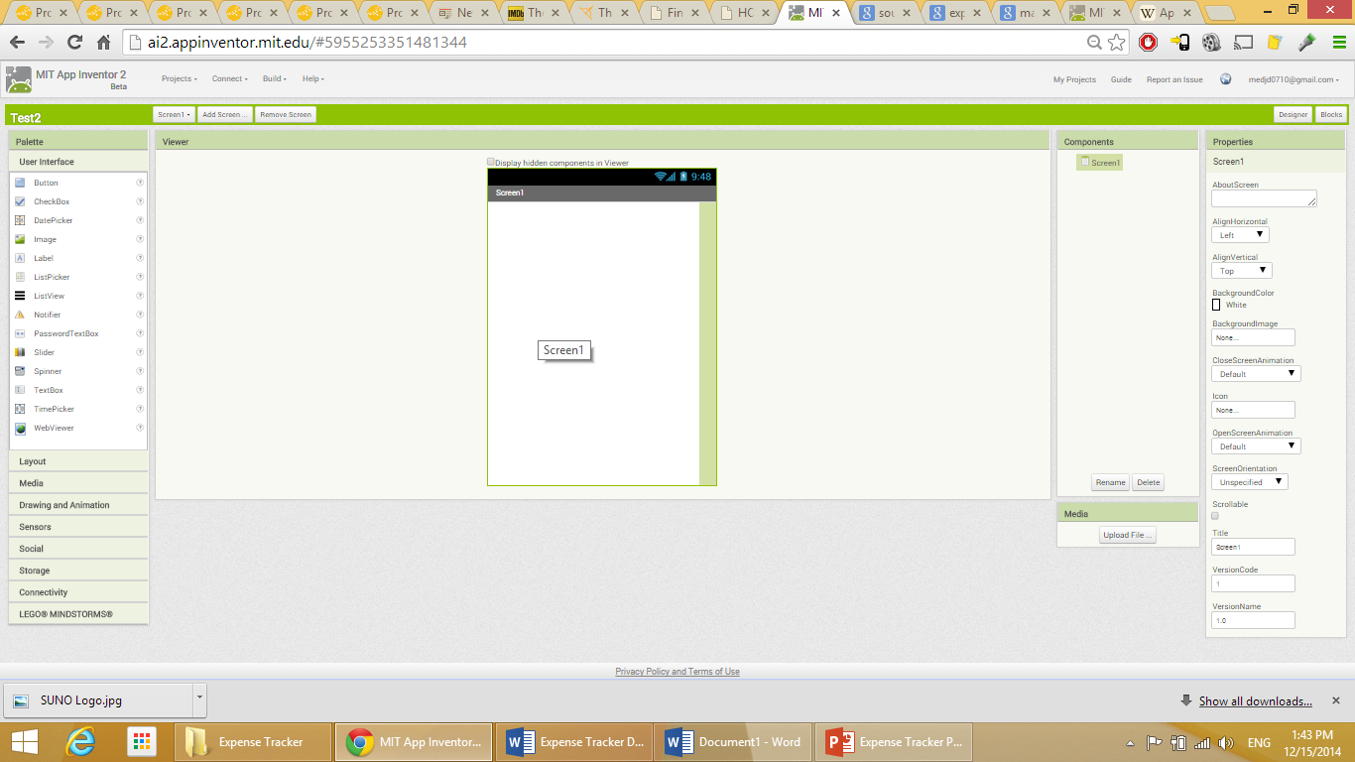

Figure 4: New Project Page

Through this screen, users can start building their app. Detailed instructions will be provided in the section below.

# Building Expense Tracker

## Home Screen “Screen1”

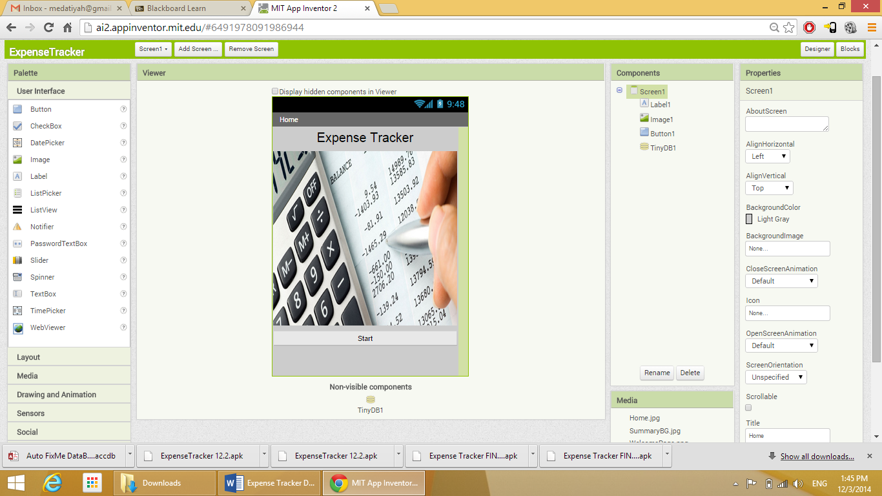

Figure 5: Screen1

As soon as the user starts a new project, a new screen will be created under the name “Screen 1”. For my app, I used this as my home screen.

Any element in the screen is created by dragging the item from the tools available on the left side of the screen. The label characteristics are adjusted as desired from the properties list on the right hand side of the screen.

After the elements of the screen are created, the coding part is done by navigating to the “Blocks” section from the right top part of the screen. Basically, the elements are created in the “Designer” section, and the coding is done at the “Blocks” section. This screen “Designer” consists of the following:

* Label: this label is used as the title of the screen/app “Expense Tracker”.

The properties are as the following:

* Text: Expense Tracker.
* Width: Fill parent.
* Image: an image for the screen.

The properties are as the following:

* Picture: I uploaded a picture for my computer.
* Width: Fill parent.
* Height: 300 pixels.
* Button: a button to take the user to the next screen of the app.

The properties are as the following:

* Text: Start.
* Width: fill parent.
* TinyDB1: to save the vales of the app in a database.

The “Blocks” part consists of:

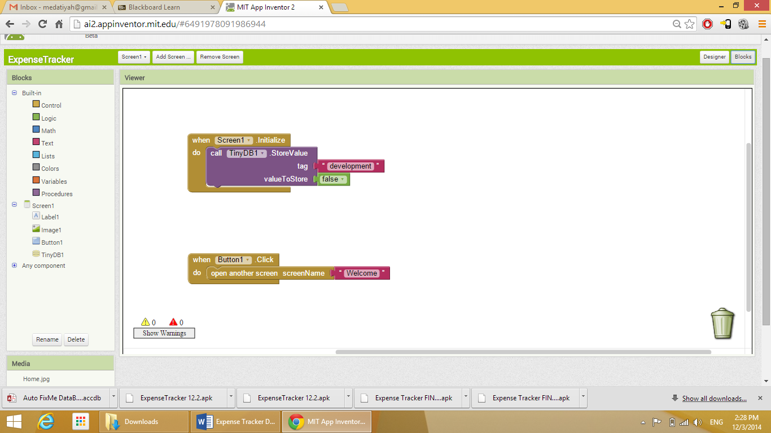

Figure 6: Screen1 Blocks

The first part: As soon as the screen is initialized, the database is called to store values. Since no value are entered in this page, the “valueToStore” is set to “false”.

The second part: This part to configure the action of the button. When the button is clicked, open another screen that is called “Welcome”.

## Welcome Screen

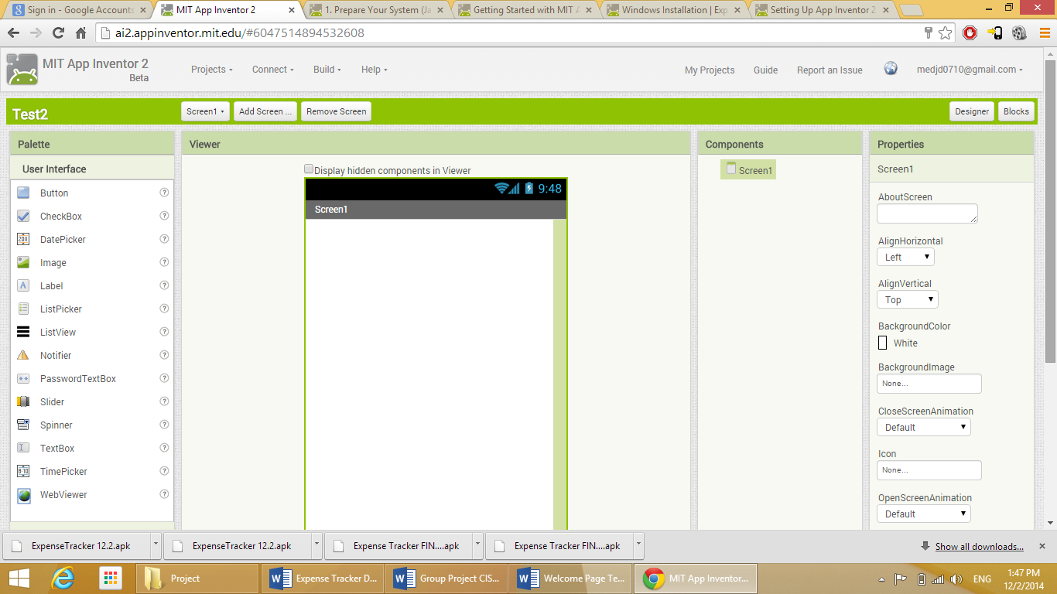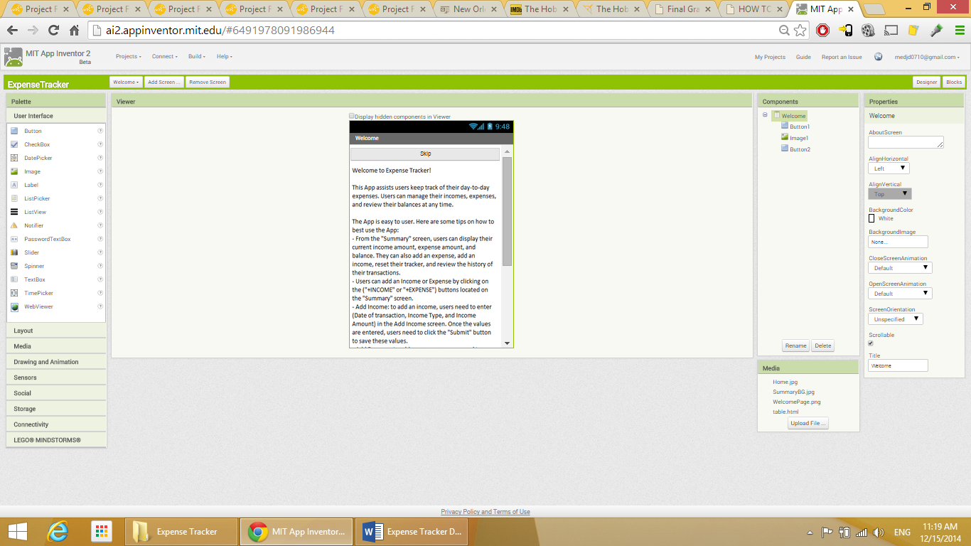

Figure 7: Welcome Screen Designer View

This screen “Designer” consists of the following:

* Button: a button to take the user to the next screen.

Button properties:

* Text: Skip.
* Width: fill parent.
* Image: this image consists of text that I created via “Paint” and saved as an image. App Inventor is not very friendly when it comes to adding long text, so I chose to enter the text using another software and embedded it to the screen as an image.

Image properties:

* Picture: picture uploaded from my computer.
* Width: fill parent.
* Button: this button is to take the user to the next screen.

Button properties:

* Text: Start using Expense Tracker.
* Width: fill parent.

I also checked the “Scrollable” checkbox from the properties of the screen since the elements entered exceed the default size of the screen.

The “Blocks” part:

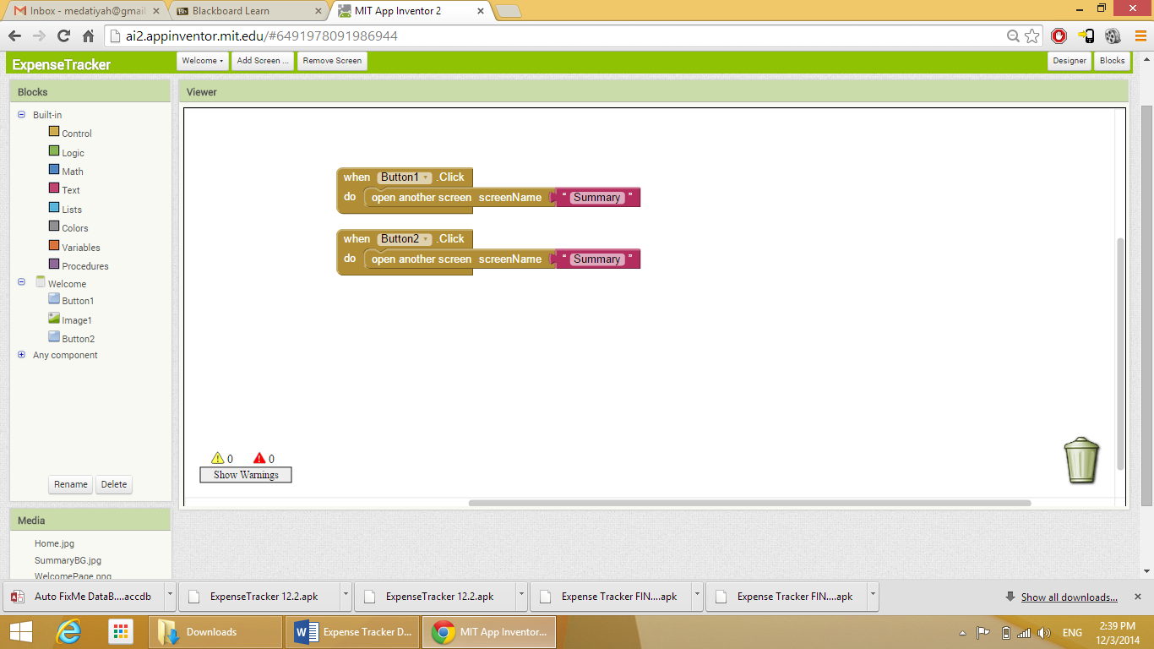

Figure 8: Welcome Screen Blocks

The first part is for the “Skip” button. When the button is clicked, the app takes the user to the next page. The second part is for the “Start using Expense Tracker”” button. When the button is clicked, the app takes the user to the next page.

## Summary Screen

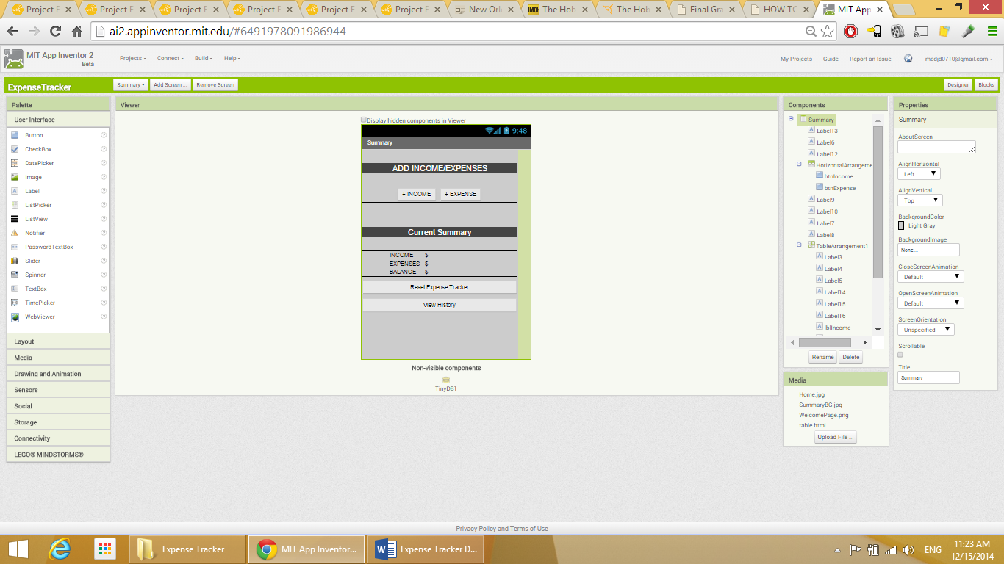

Figure 9: Summary Screen Designer View

This screen “Designer” consists of the following:

* Label: screen title.

Label properties:

* BackgroundColor: Dark Gray.
* Text: ADD INCOME/EXPENSES
* TextColor: White.
* Width: fill parent.
* HorizontalArrangement: To add two labels within the same “Row”

Properties:

* AlignHorizontal: Center.
* Width: fill parent.

Within this HorizontalArrangement:

* Button: a button to take the user to the Add Income screen.

Properties:

* Text: +INCOME.
* Width: fill parent.
* Button: a button to take the user to the Add Expense screen.

Properties:

* Text: +EXPENSE.
* Width: fill parent.
* Label: a title for the next part of the screen.

Properties:

* BackgroundColor: Dark Gray.
* Text: Current Summary.
* TextColor: White.
* Width: fill parent.
* TableArrangement: a table to add several elements in a table/grid style. Used for better organization and layout of the elements.

Properties:

Columns: 4.

Rows: 3.

Width: fill parent.

Within the Table Arrangement:

* Label: to display the description of the data displayed in this raw.

Properties:

* Text: INCOME.
* Label: to display the dollar sign.

Properties:

* Text: $.
* Label: to display the description of the data displayed in this raw.

Properties:

* Text: EXPENSES.
* Label: to display the description of the data displayed in this raw.

Properties:

* Text: BALANCE.

NOTE: There are three blank labels which will display the Income, Expenses, and Balance amounts in the table. More details on this will be mentioned at the “Blocks” section of this screen.

* Button: a button to reset all values in the app database.

Properties:

* Text: Reset Expense Tracker.
* Width: fill parent.
* Button: a button to take the user to the history screen.

Properties:

* Text: View History.
* Width: fill parent.
* TinyDB: a database to save the values.

The “Blocks” section:

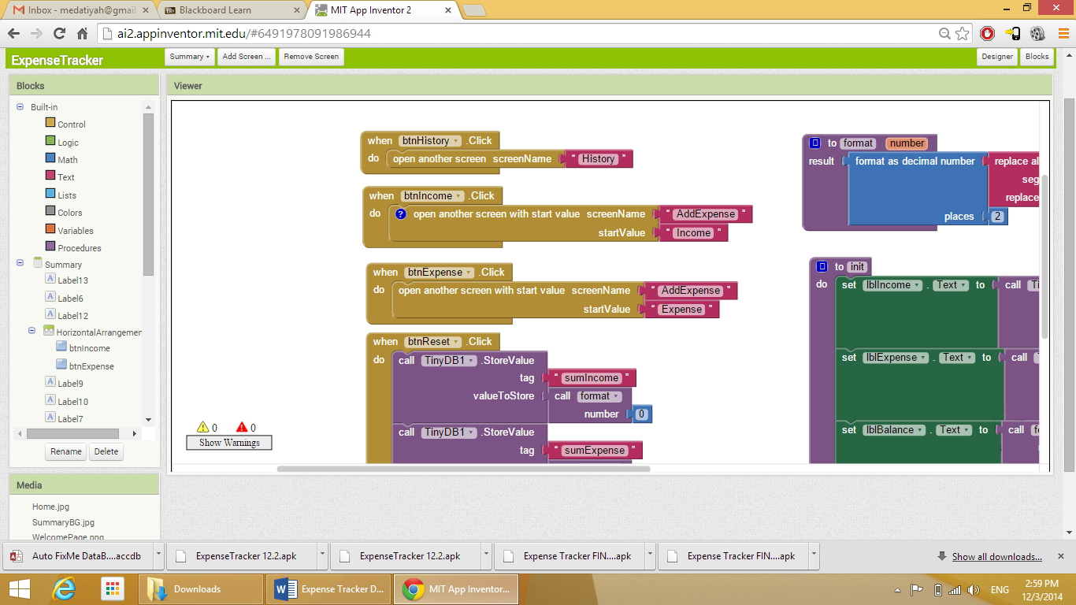

Figure 10: Summary Screen Blocks 1

This is the code for the “History” button. When the button is clicked, the app takes the user to the “History” screen.

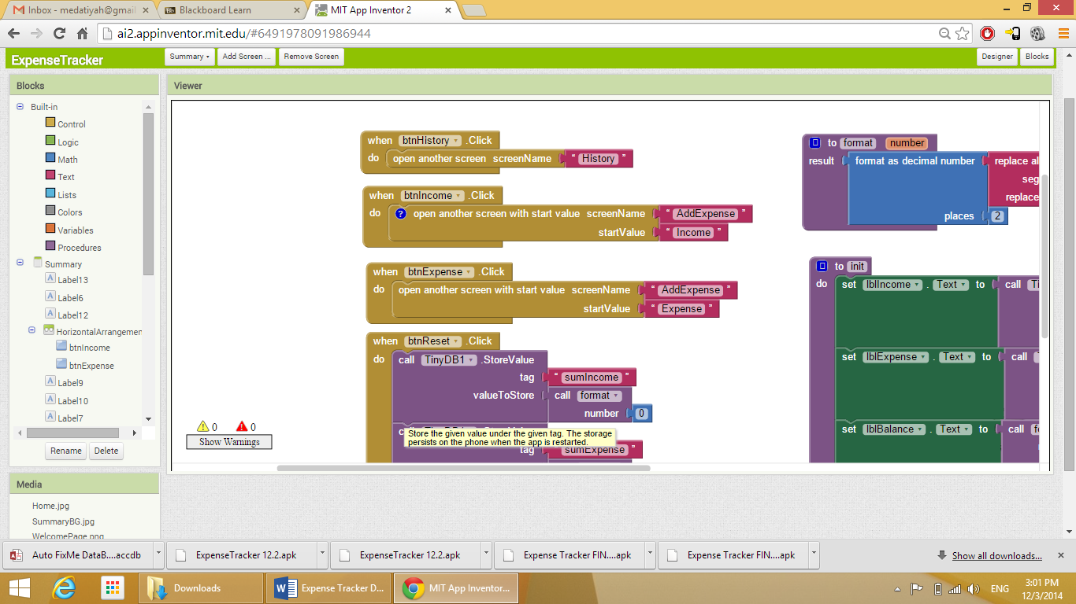

Figure 11: Summary Screen Blocks 2

This is the code for the “Add Income” button. When the button is clicked, the app takes the user to the “Add Expense” screen and sets a start value as “Income” which will set the title of the screen to “Income”.

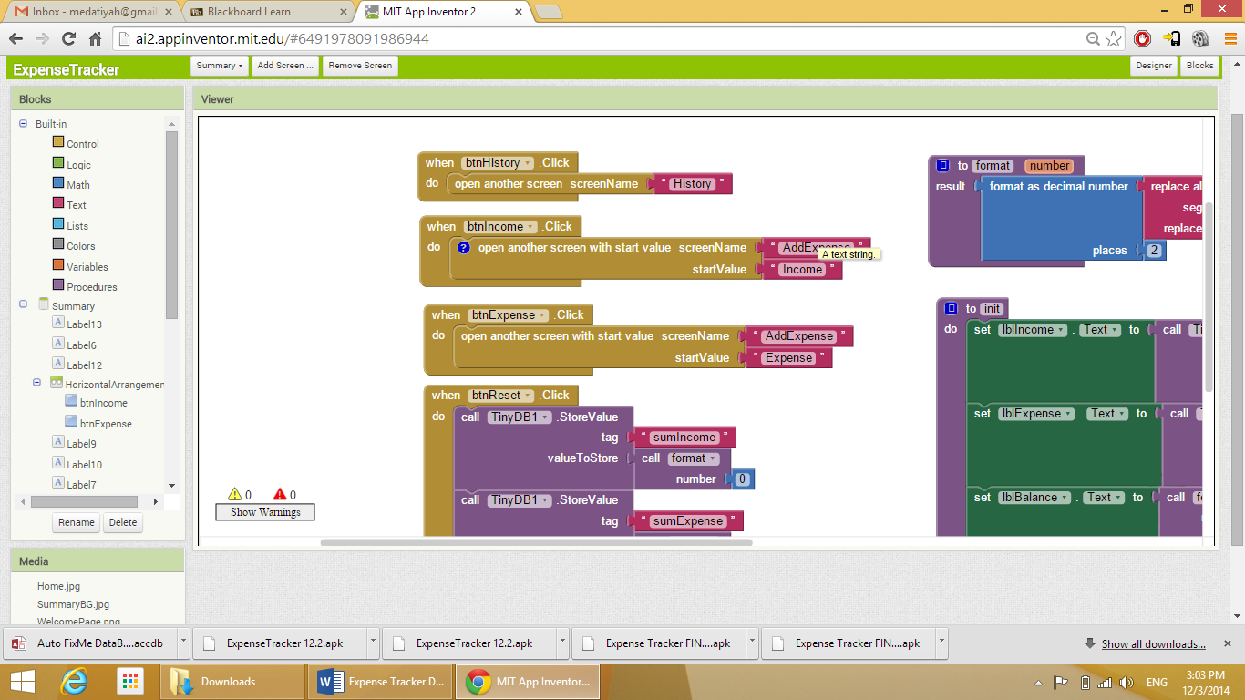

Figure 12: Summary Screen Blocks 3

This is the code for the “Add Expense” button. When the button is clicked, the app takes the user to the “Add Expense” screen and sets a start value as “Expense” which will set the title of the screen to “Expense”.

I used the same screen to Add Income and Add Expense. This will be explained in details at a later stage.

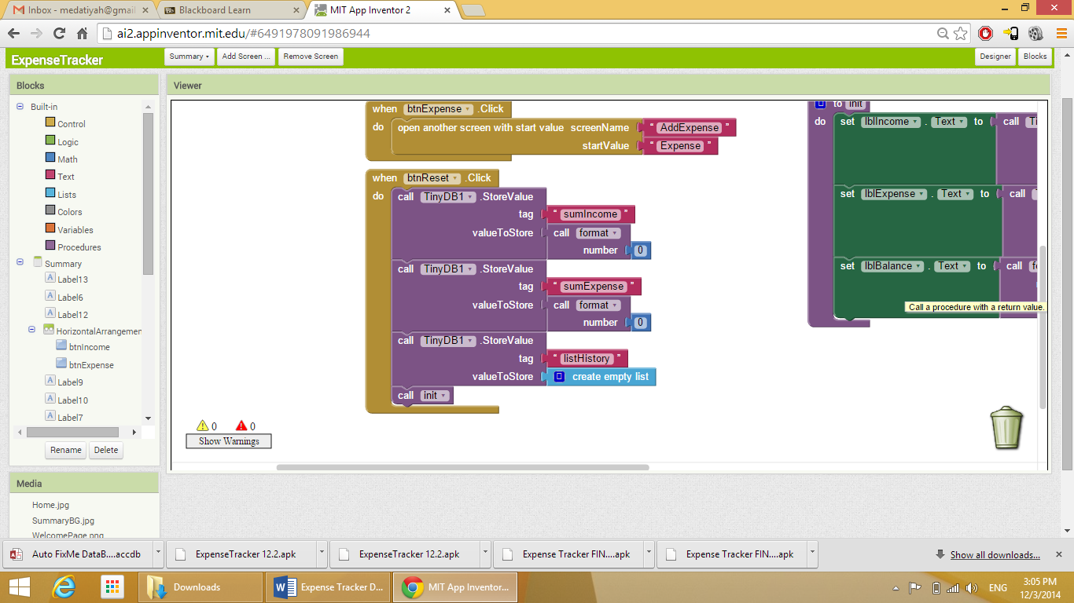

Figure 13: Summary Screen Blocks 4

This code is the set the function of the “Reset” button. As soon as the button is clicked, the app is requested to call the DB and reset all values to zero using the “format” function. The functionality of “format” will be explained later. This button also calls a function called “init".

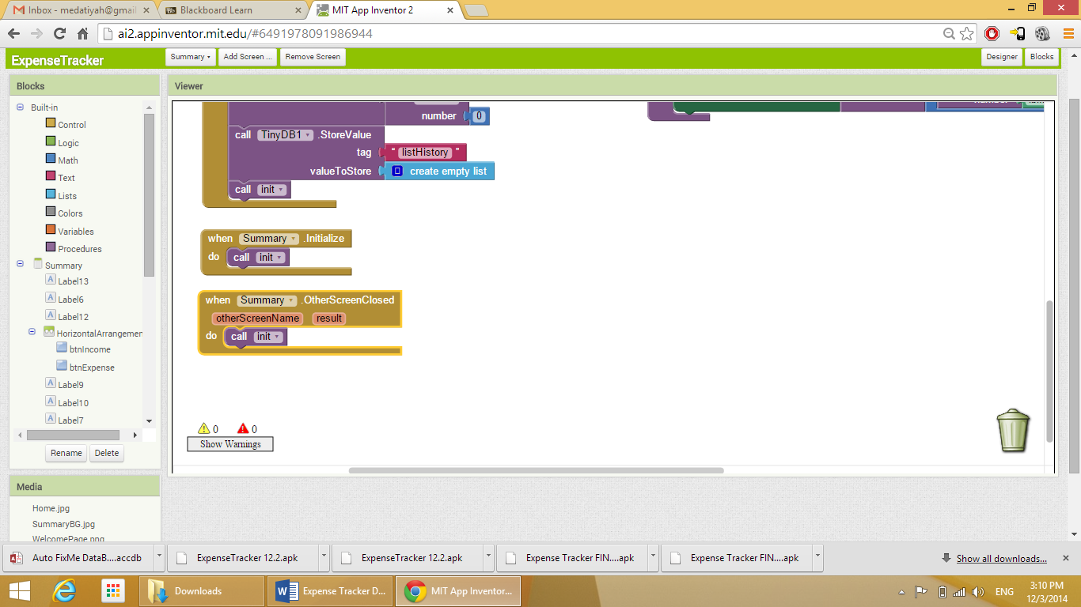

Figure 14: Summary Screen Blocks 5

The first part: as soon as the “Summary” screen is initialized, the app calls the function “init. The second part: as soon as the other screen (Any screen that was open before the “Summary” screen) the app calls the function “init”. The functionality of the function “init” will be explained later.

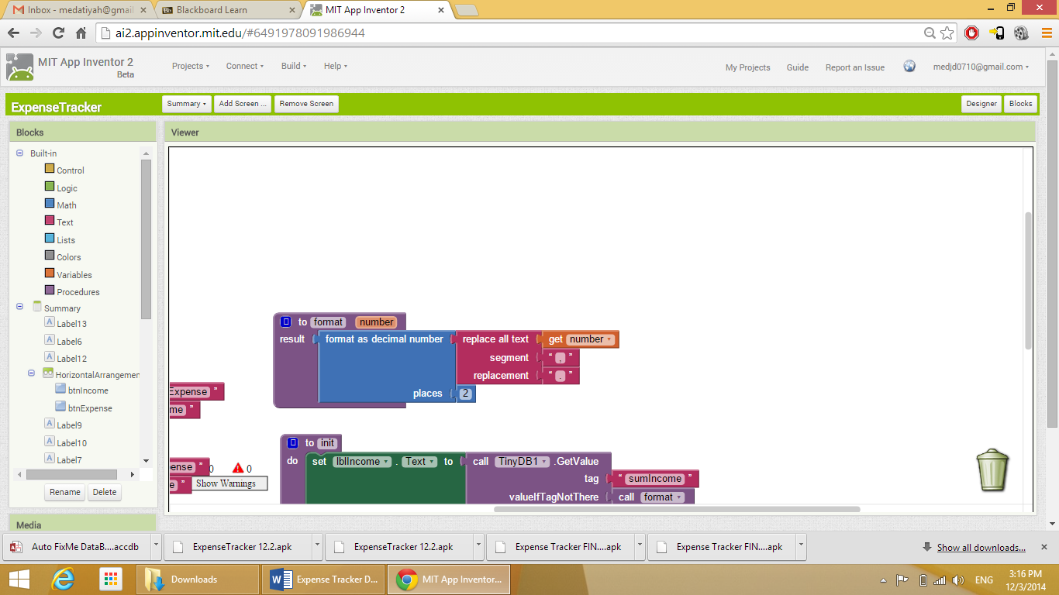

Figure 15: Summary Screen Blocks 6

This code is to configure the function “format”. The function does the following:

* Initialize a variable called “number” and sets the data type to “decimal”.
* Set the decimal places to 2.
* Set the separation symbol to “.”.

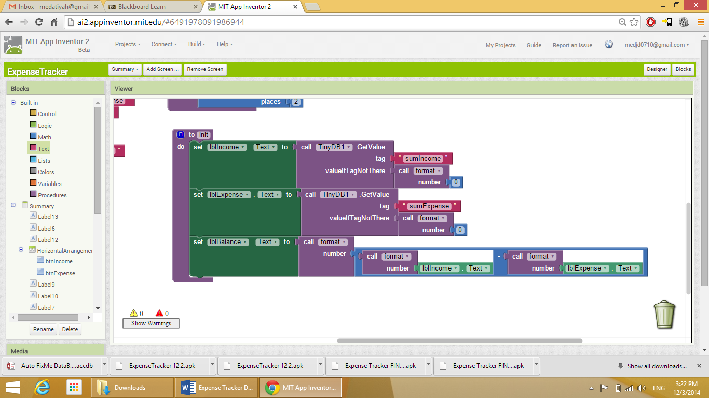

Figure 16: Summary Screen Blocks 7

This code is to set the functionality of the function “init”. This function does the following:

* Set the text of the blank label that displays the Income amount to “0” using the “format” function.
* Set the text of the blank label that displays the Expenses amount to “0” using the “format” function.
* Set the test of the blank label that displays the Balance amount to (The subtraction of the Expenses amount from the Income amount) using the “format” function.

## Add Income/Expense Screen

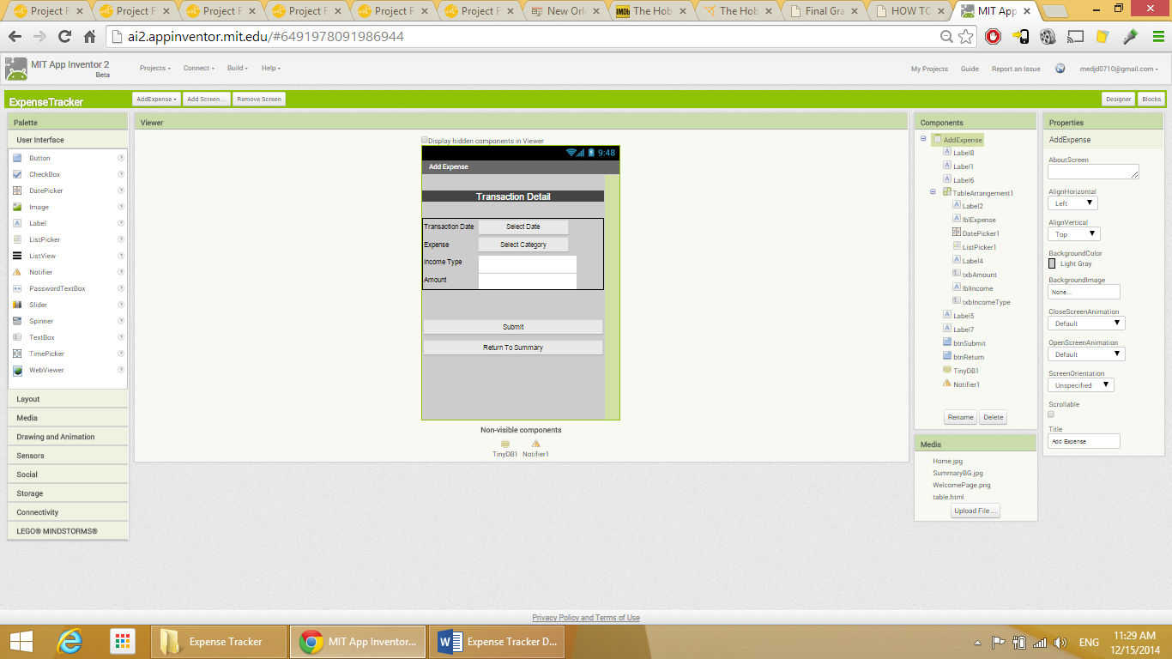

Figure 17: AddExpense Screen Designer View

This screen “Designer” consists of the following:

* Label: screen title.

Label properties:

* BackgroundColor: Dark gray.
* FontSize: 18.
* TextAlignment: Center.
* TextColor: White.
* Width: Fill parent.
* TableArrangement:

Properties:

* Columns: 2.
* Rows: 4.
* Width: Fill parent.

This Table Arrangement consists of the following:

* Label: title for Transaction Date.

Properties:

* Text: Transaction Date.
* DatePicker: to allow the user choose the transaction date.

Properties:

* Text: Select Date.
* TextAlignment: Center.
* Label: title for Expense Type.

Properties:

* Text: Expense.
* ListPicker: to allow the user choose the expense type.

Properties:

* Text: Select Category.
* TextAlignment: Center.
* Label: Income Type. This label displays the title for the income type field.

Properties:

* Text: Income Type.
* TextBox: to allow the user to enter the income type.

Properties:

* Hint: Enter Income Type.
* Label: Amount. This label displays the title for the income amount field.

Properties:

* Text: Amount.
* TextBox: to allow the user to enter the income amount.

Properties:

* Hint: Enter Income Type.
* Button: Submit. Allows user to submit the transaction.

Properties:

* Text: Submit.
* Width: Fill parent.
* Button: Return to Summary. Allows user to return to Summary screen.

Properties:

* Text: Return To Summary.
* Width: Fill parent.

The “Blocks” part of this screen:

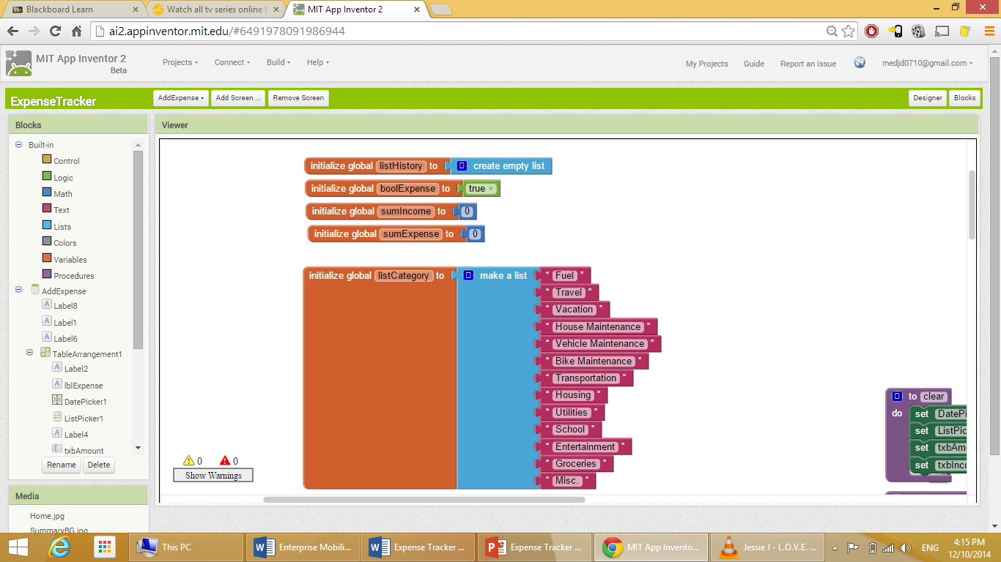

Figure 18: AddExpense Screen Blocks 1

This code is to initialize the following variables:

* listHistory: a list to save the data for the History screen.
* boolExpense: a Boolean variable to return a True or False value.
* sumIncome: a variable to save the sum of income values.
* sumExpense: a variable to save the sum of expense values.

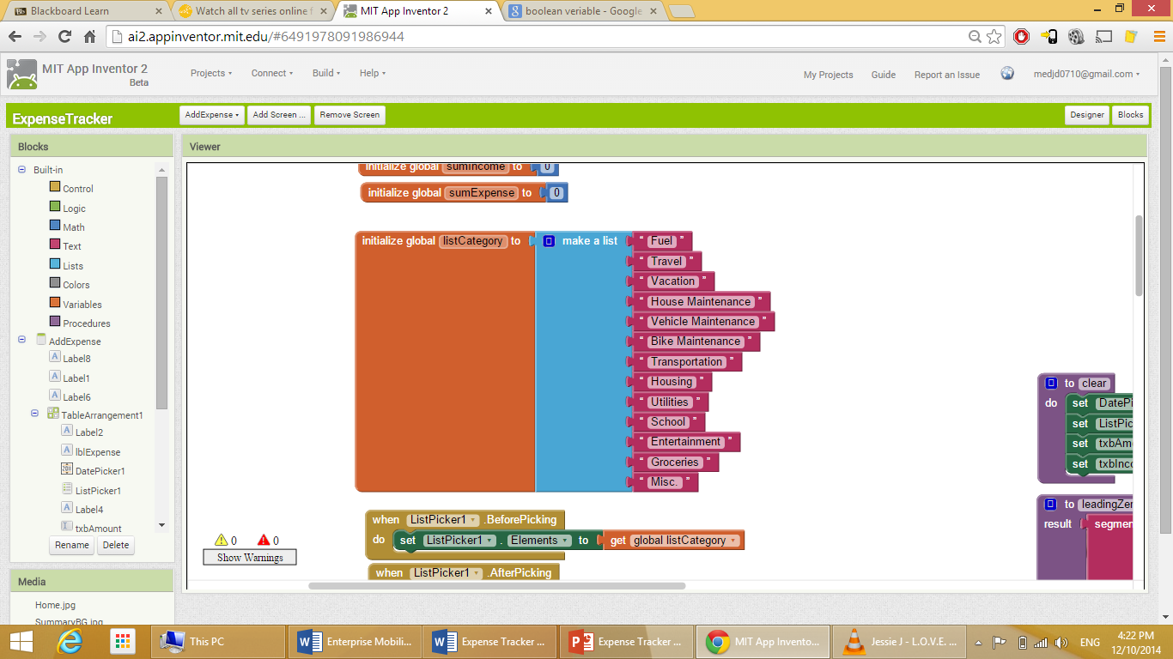

Figure 19: AddExpense Screen Blocks 2

A code to initialize a variable (global listCategory) and save the values for the drop-down-menu associated with the expense category listPicker in this variable.

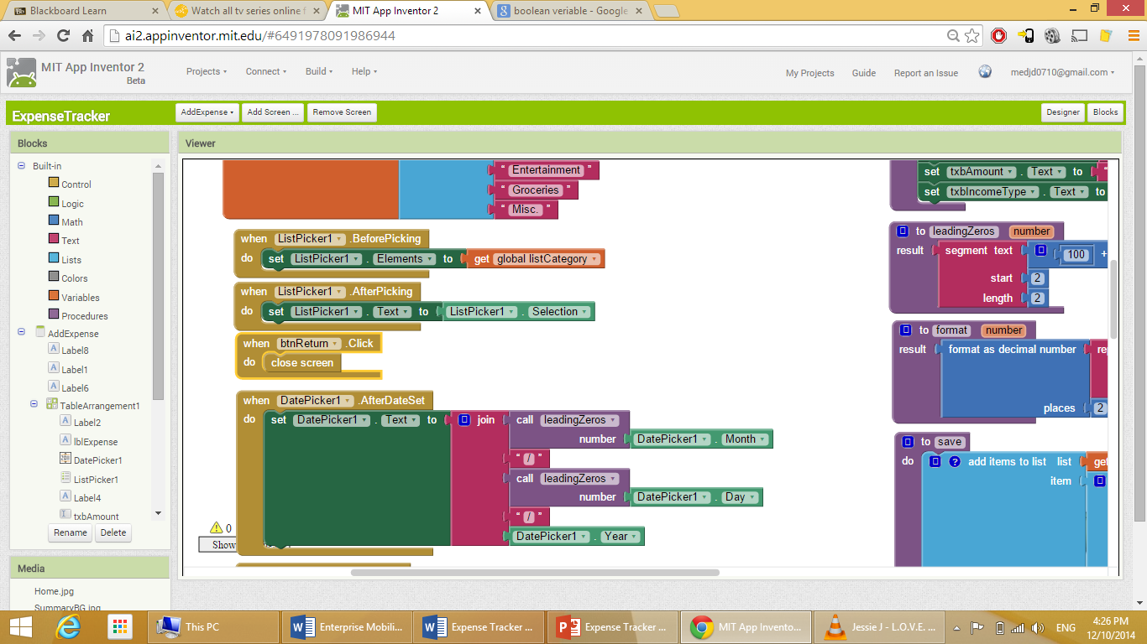

Figure 20: AddExpense Screen Blocks 3

Fist code is to set the elements of the listPicker to the values saved in the global listCategory list created above. Second code is to set the text of the listPicker to the selected value. Third code is to close the screen once the “Return to Summary Screen” button is clicked.

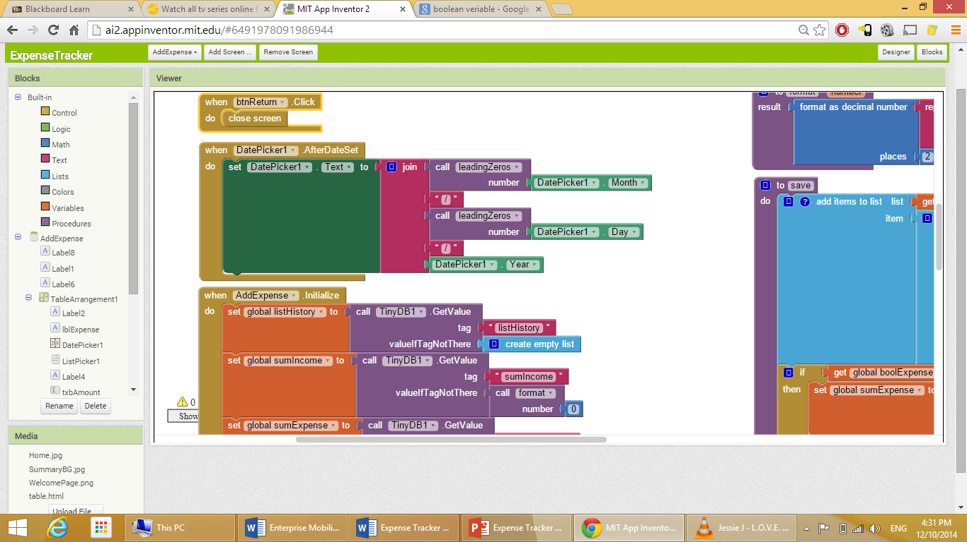

Figure 21: AddExpense Screen Blocks 4

This code is set the text of the datePicker to the selected date with the symbol “/” as a separator.

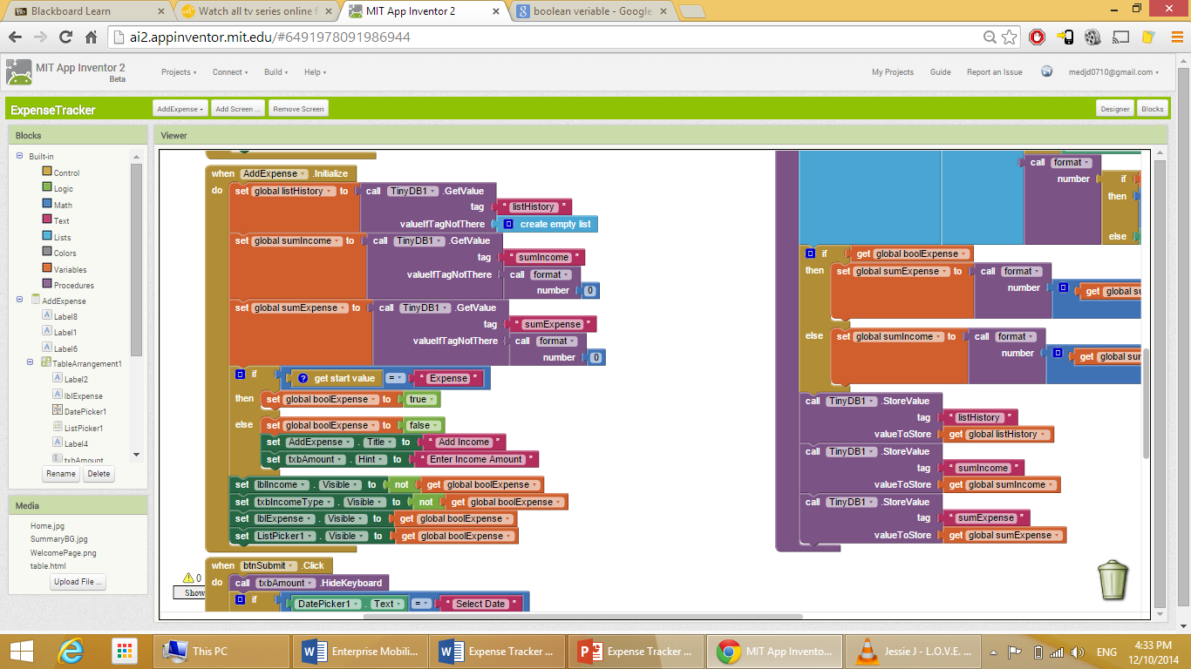

Figure 22: AddExpense Screen Blocks 5

This code is to do the following:

* As soon as the “AddExpense” screen is initialized, call the TinyDB and set the values of the global listHistory variable to a new variable called “listHistory” which will be saved in the DB.
* Call the TinyDB and set the values of the global sumIncome variable to a new variable called “sumIncome” which will be saved in the DB.
* Call the TinyDB and set the values of the global sumExpense variable to a new variable called “sumExpense” which will be saved in the DB.
* If the start value is “Expense” that means the button that was clicked to get to this screen is the “+EXPENSE” button. If that’s the case, set the boolExpense to “True”. Else, set boolExpense to “false”, set the screen title to “Add Income”, and set the text of the Amount label hint to “Enter Income Amount”.
* Set the income label visibility to opposite of the value of global boolExpense.
* Set the visibility of textbox for income type visibility to opposite of the value of global boolExpense.
* Set the visibility of expense type label to the value of global boolExpense.
* Set the visibility of expense type listPicker to the value of global boolExpense.

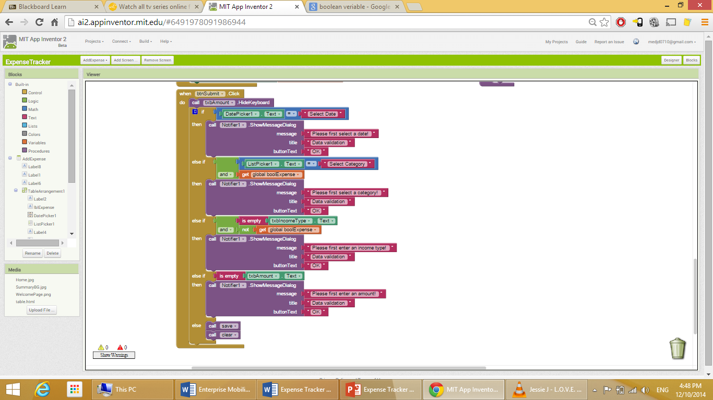

Figure 23: AddExpense Screen Blocks 6

When the button “Submit” is clicked do the following:

* Hide keyboard.
* If the user didn’t select a date, show a message saying “Please first select a date!”.
* Same for the other fields, making it mandatory for the user to enter data in all fields to avoid any errors in the data.
* Call the functions “save” and “clear” which will be explained later.

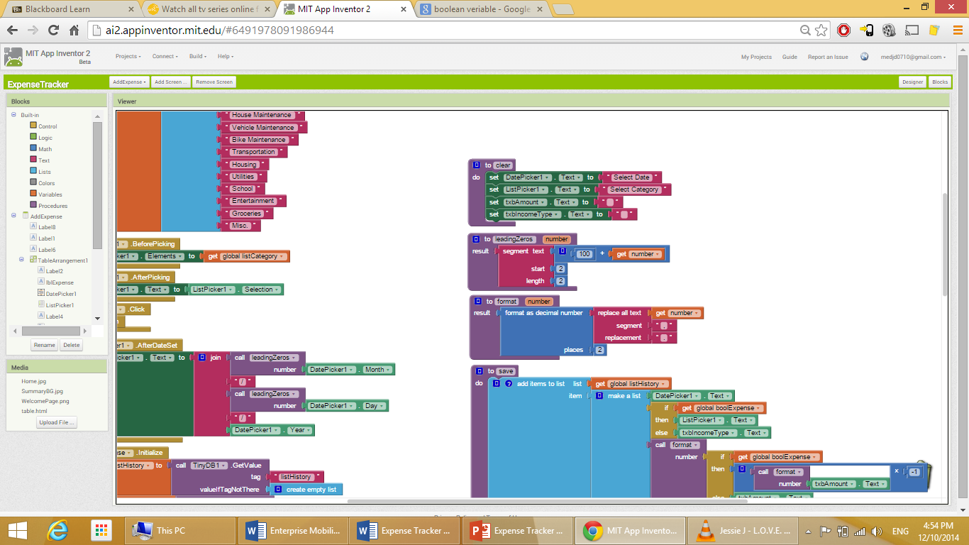

Figure 24: AddExpense Screen Blocks 7

The “clear” function: Set the text of DataPicker, listPicker, Amount textbox, and Income Type textBox to the default values.

The “leadingZeros” function: to make sure whatever the value enter by the user is, it will be displayed in the format of two digit numbers. This is accomplished by adding the value entered by the user to 100. Then select the text to display starting from the second character, and choose two characters from that point.

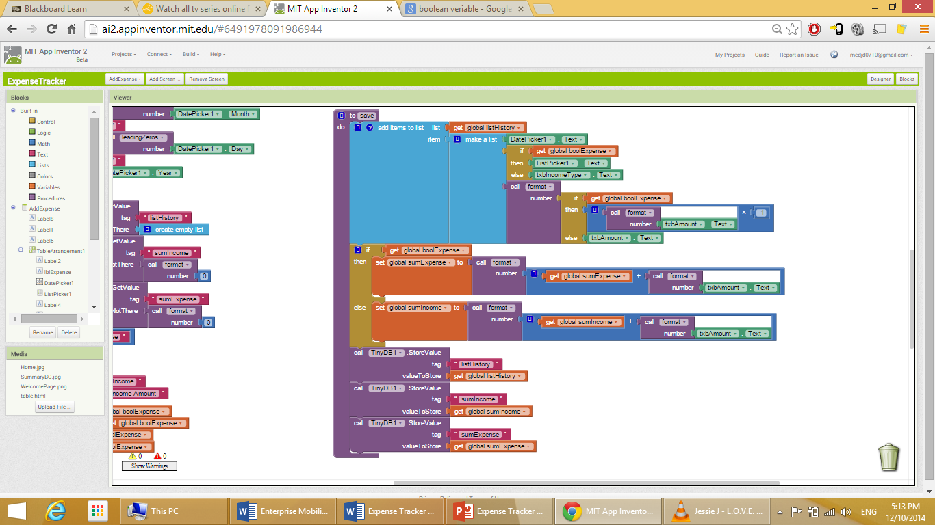

Figure 25: AddExpense Screen Blocks 8

The “save” function does the following:

* If the global boolExpense variable value is “True” that means the app will be working on the expense part. Otherwise, it will work on the income part.
* If expense: save get the listHistory variable and assign the following data to it: the transaction date (From datePicker), expense category (From listPicker), and the negative value of the text amount value entered by the user. Then add the value entered in the amount field to the sumExpense variable.
* Else (Working on the income side), save the values related to the income in a list in the global listHistory variable. And then add the value entered in the amount field to the sumIncome variable.
* After that, call the DB and save global listHistory as listHistory, global sumIncome as sumIncome, and global sumExpense as sumExpense.

## History Screen

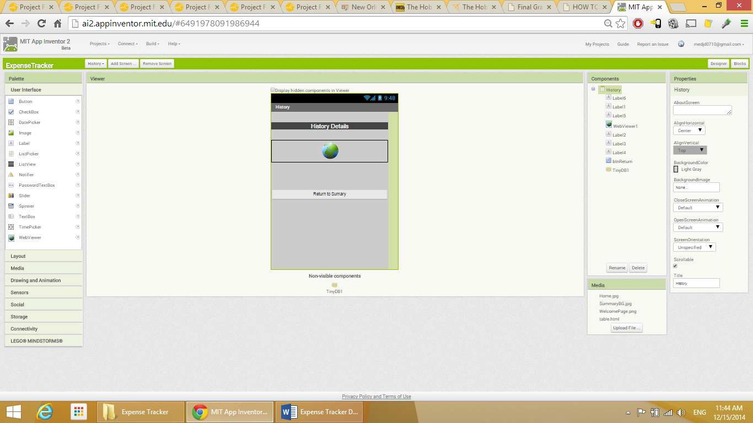

Figure 26: History Screen Designer View

The “Designer” section consists of the following:

* Label: screen title.

Properties:

* BackgroundColor: Dark gray.
* FontSize: 18.
* TextColor: White.
* Width: Fill parent.
* WebViewer: to view the history of all transaction entered by the user.

Properties:

* Width: Fill parent.
* Height: Fill parent.
* Button: to take the user back to Summary screen.

Properties:

* Text: Return to Summary.
* Width: Fill parent.

The “Blocks” section:

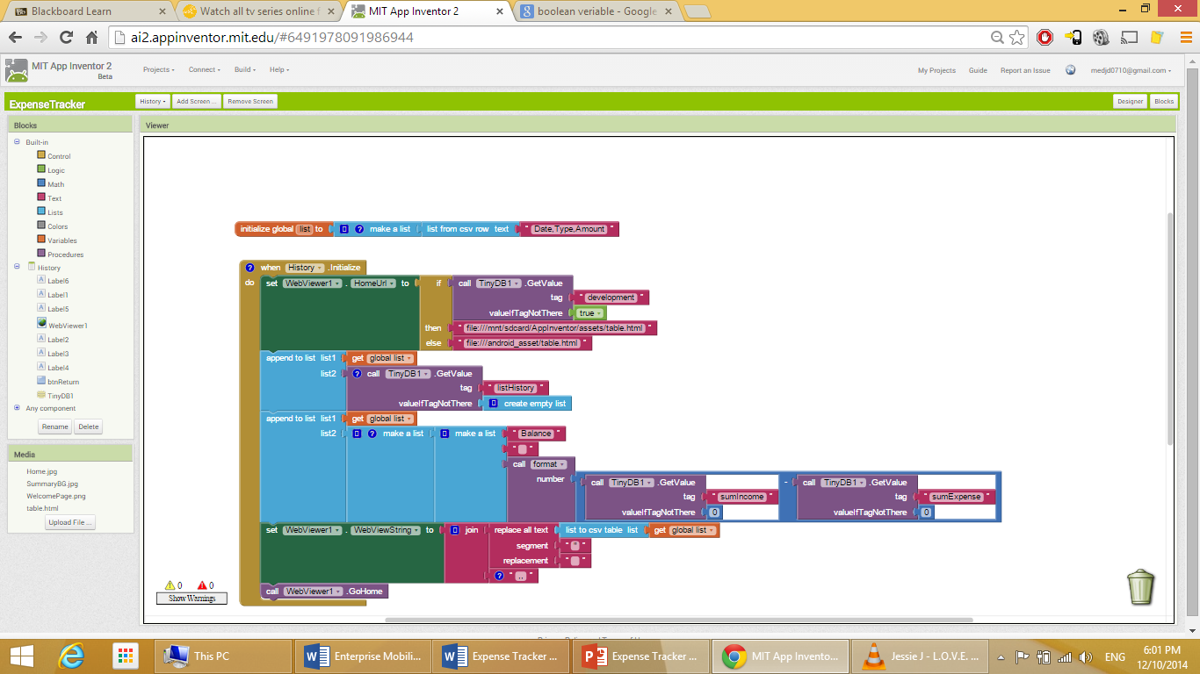

Figure 27: History Screen Blocks 1

To initialize a variable called “list” which is a csz row (Excel sheet style) with column titles as Date, Type, and Amount.



Figure 28: History Screen Blocks 2

As soon as the “History” screen is initialized do the following:

* Set the “Home URL” of the webViwer.
* Call the DB, create an empty list under the tag name “listHistory”, and append that list to the variable global list.
* Append to the list the sumExpense value subtracted from the sumIncome value under the field “Balance”.
* Set the webViewer “WebViewString” to display the lists.
* Call the webViwer home.

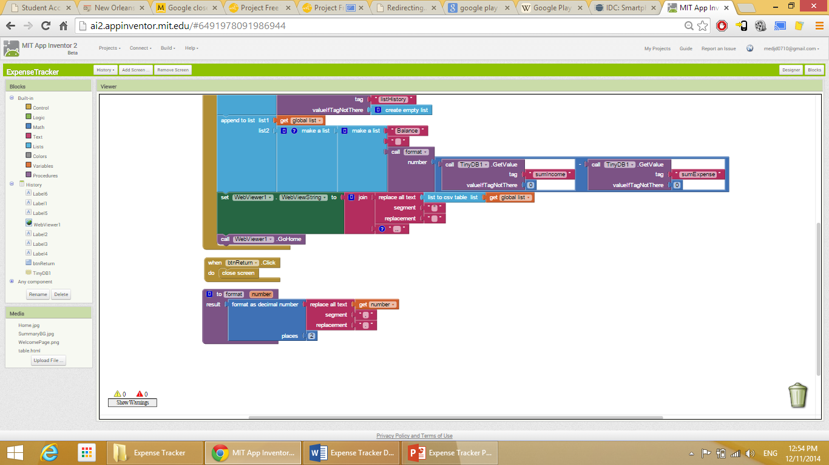

Figure 29: History Screen Blocks 3

When the “Return to Summary” button is clicked, take the user to the Summary screen.

The “format” function works in the same way as the “format” function explained/used earlier.

# References

Khalaf, S. (2013, April 3). *Flurry Five-Year Report: It’s an App World. The Web Just Lives in It.* Retrieved from <http://www.flurry.com/bid/95723/Flurry-Five-Year-Report-It-s-an-App-World-The-Web-Just-Lives-in-It#.VGzHafnF9UU>

International Data Corporation (IDC) (2013, April 10). *PC shipments post the steepest decline ever in a single quarter, according to IDC*. [Press release]. Retrieved from <http://www.idc.com/getdoc.jsp?containerId=prUS24065413>.

Clark, J. (2013) *History of mobile applications* [PDF document]. Retrieved from <http://www.uky.edu/~jclark/mas490apps/lectures.html>.

MIT App Inventor (No Date). *Getting Started With MIT App Inventor 2*. Retrieved from <http://appinventor.mit.edu/explore/get-started.html>

Honan, M. (2007, January 9). *Apple unveils iPhone.* Retrieved from <http://www.macworld.com/article/1054769/iphone.html>

Brill, E. (2013, October 7). *Mobile computing: it’s a game changer for companies.* Retrieved from <http://www.theatlantic.com/sponsored/ibm-mobile/2013/10/mobile-computing-its-game-changer-companies/32/>.

MIT App Inventor (No Date). *Prepare Your System (Java)*. Retrieved from <http://appinventor.mit.edu/explore/test-your-system.html>

International Data Corporation (IDC) (2013, April 25). *More smartphones were shipped in Q1 2013 than feature phones, an industry first according to IDC.* [Press release]. Retrieved from <http://www.idc.com/getdoc.jsp?containerId=prUS24085413>.

Sterling, G. (2013, November 14). *Report: REI has best mobile site of top 100 retailers, Apple the worst.* Retrieved from <http://marketingland.com/report-rei-has-best-mobile-performance-of-top-100-retailers-apple-the-worst-65139>.

Cisco Systems, Inc. (2013, August 29). *Device freedom without compromising the IT network*. Retrieved from <http://www.cisco.com/en/US/docs/solutions/Enterprise/Borderless_Networks/Unified_Access/byodwp.pdf>.

MIT App Inventor (No Date). *Designer and Blocks Editor*. Retrieved from <http://appinventor.mit.edu/explore/designer-blocks.html>

Patrick-Smith, T. (2012, December 10). *The move from BYOD to CYOD*. Message posted to <http://www.cbronline.com/blogs/cbr-rolling-blog/guest-blog-the-move-from-byod-to-cyod-101212>.

International Data Corporation (IDC) (2014, Q3). *Smartphone OS Market Share, Q3 2014*. Retrieved from <http://www.idc.com/prodserv/smartphone-os-market-share.jsp>